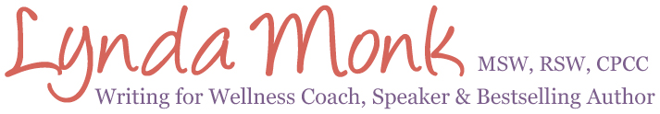
Media Kit
Lynda is a gifted storyteller who customizes every keynote and interview for your unique audience. She believes every talk has the power to create lasting impact, inspire learning and change lives.
Contact Information
Lynda Monk, MSW, RSW, CPCC
Creative Wellness | Write to Awaken, Heal & Transform
Email: lynda@creativewellnessworks.com
Phone: (250) 653-2085
Lynda’s Photos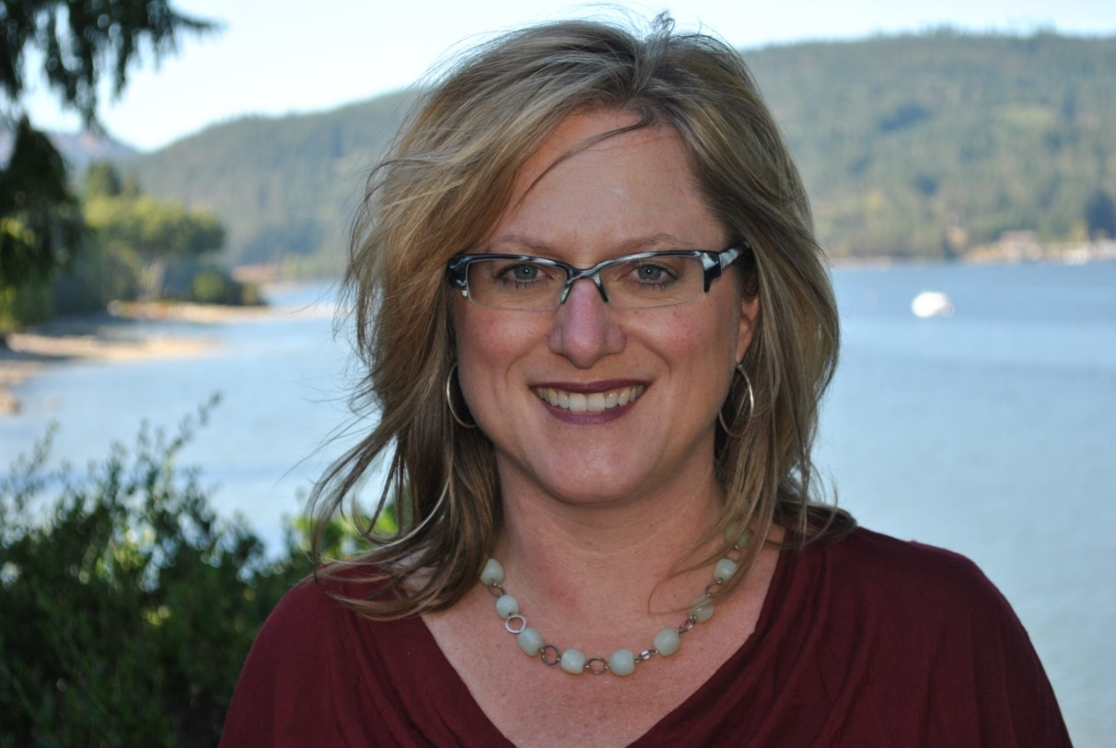
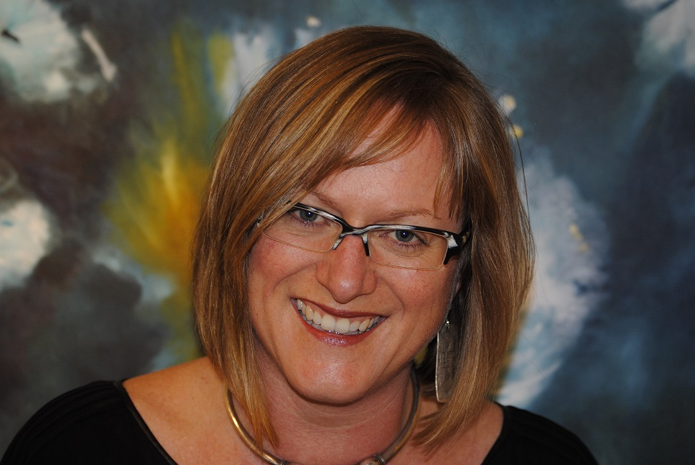

Lynda was an absolute pleasure to work with and went above and beyond in both the promotion of our event as well as an outstanding delivery on writing for wellness. Her willingness to spend time tailoring the presentation to our audience was most appreciated! I wish all the speakers I worked with could be as generous and passionate about the outcome of their efforts as Lynda is!
~ Shannon Sullivan, CHHC, Whole Food Love

Lynda’s Bio
Lynda Monk, MSW, RSW, CPCC, Founder of Creative Wellness, is a Writing for Wellness Coach, Speaker and Bestselling Author. She is passionate about supporting people to use expressive writing to improve emotional, physical, psychological and spiritual health. She is the co-author of Writing Alone Together: Journalling in a Circle of Women for Creativity, Compassion and Connection, as well as the international bestseller Inspiration for a Woman’s Soul: Choosing Happiness. Lynda offers inspirational Writing for Wellness workshops, coaching programs, retreats and products that guide individuals and groups to engage in the healing and transformational power of writing. Lynda lives with her family on Salt Spring Island, British Columbia where she does her best to write every day. Get your complimentary Writing for Wellness Kit at http://CreativeWellnessWorks.com

Having Lynda as a guest expert on JournalTalk is both a refreshing and invigorating experience. She knows how to share the magic of new possibilities with an audience, in a simple, inspirational and informative style. We're ready to have her back again anytime!
Nathan Ohren, EasyJournaling.com

Lynda’s Social Media Communities
Lynda’s Popular Speaking Topics
Write Your Way to Clarity & Calm – Lynda will take your audience to the page to gain clarity, make decisions, get grounded and access deeper feelings of calm and well-being. During this experiential keynote participants will have a first-hand experience with the transformational power of expressive writing.
Beyond Bubble Baths: Self-Care for Helpers, Healers and Caregivers through Therapeutic Journaling – Lynda brings together the key elements of burnout prevention alongside the healing benefits of expressive writing to offer those who care for others, a powerful tool for self-care, reflective practice and replenishment. Expressive writing is a proven way to help prevent burnout and mitigate the risk for vicarious trauma and compassion fatigue, common occupational hazards within helping and healthcare professions. Learn how Lynda used journaling to reduce stress in high trauma work as a crisis response social worker.
Write from Within for Wellness – Learn how to tap into your inner ways of knowing (intuition) through guided meditation and expressive writing. Discover key strategies for writing to improve emotional, physical, psychological and spiritual health. This inspirational talk will inspire audiences to take charge of their health and wellness in creative and courageous ways.

Lynda Monk's authentic and easy-going style made her one of my favorite people to interview as well as one of my viewer's favorite speakers to watch. Her heart-felt vulnerability really struck a chord with my viewers and her easy-to-implement writing strategies can help facilitate healing in a powerful way. I can't wait to work with her again on my next project!
Mary E. Pritchard, PhD, HHC, Psychologist & Body Love Expert, Awakening the Goddess Within

About Lynda
- Registered Social Worker and Certified Professional Co-Active Coach

- Engaging and empowering speaker featured on numerous radio shows, global telesummits, popular podcasts as well as a sought after keynote speaker for professional conferences and women’s health events.

- Co-author of Writing Alone Together: Journalling in a Community of Women for Creativity, Compassion and Connection

- Co-author of the international best-selling book Inspiration for a Woman’s Soul: Choosing Happiness

- Lynda has taken thousands of individuals to the page in both in-person workshops and retreats, as well as within online courses and events.
Lynda’s Credentials
- Masters of Social Work, University of Northern British Columbia

- Honours Bachelor of Social Work, Lakehead University

- Bachelor of Arts (Sociology), University of Western Ontario

- Certified Professional Co-Active Coach, The Coaches Training Institute (CTI)

- Memoir & Life Writing Courses, including a memoir residency at the Banff School of the Arts

Book Lynda for your next live or online event…
Email: lynda@creativewellnessworks.com
Or
Call: (250) 653-2085 Stories and words have the power to change lives!

